Assignment 24.3

Calculate the number of employees corresponding to each skill from the table 'employee' which is loaded in the Demo.

First creating the table emp and loading the data into it.

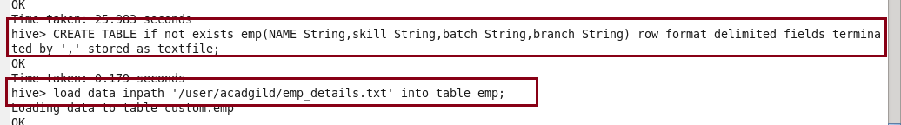

After creating the table according to the question counting the number of employees by using COUNT.

